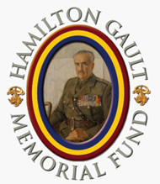
HAMILTON GAULT MEMORIAL FUND
2023 ANNUAL REPORT
The Hamilton Gault Memorial Fund (HGMF) is named after Brigadier Andrew Hamilton Gault, DSO, ED, CD, Founder of the PPCLI. It is a registered charitable organization that supports the Regiment and the Regimental Family.
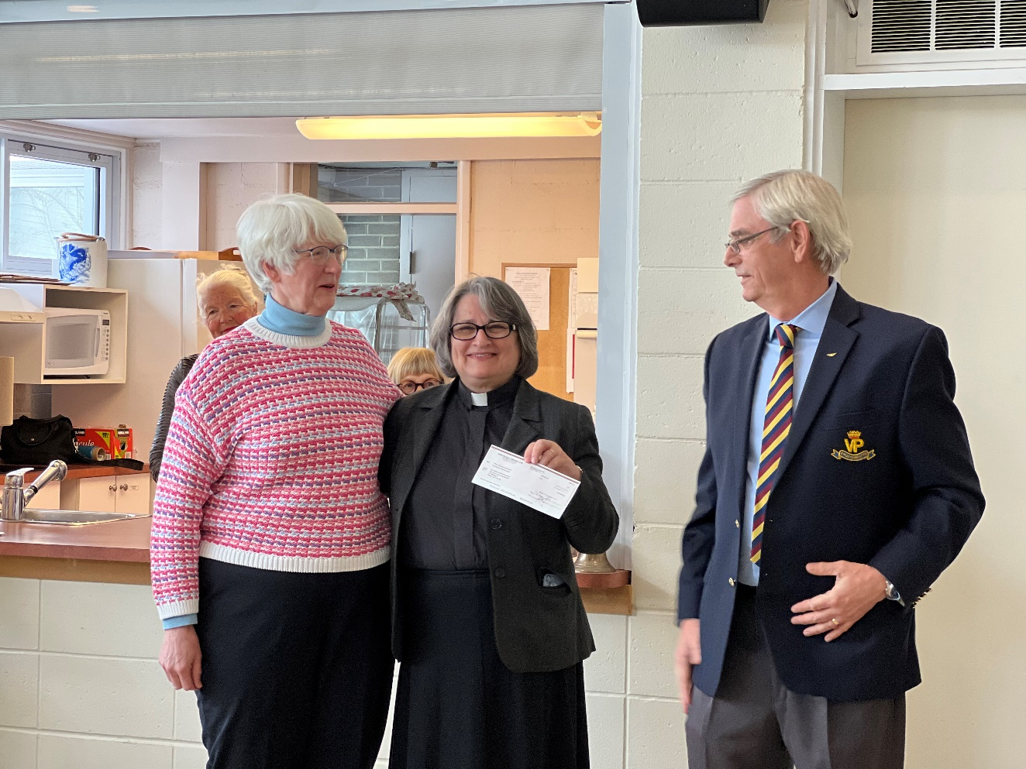
Bonnie Robertson (Fundraising Chair), Rev. Cathy Davis (Clergy), Dave Pentney (Chair HGMF)
On March 12, 2023, the Chair of the HGMF, in the company of several Patricia’s, had the honour of presenting St. Bartholomew’s Church with the final $5,000 cheque to complete our $25,000 commitment towards the restoration of the church’s stained-glass window. There is a very strong Patricia connection with this church, and this stained-glass window, even though it dates back more than a century.
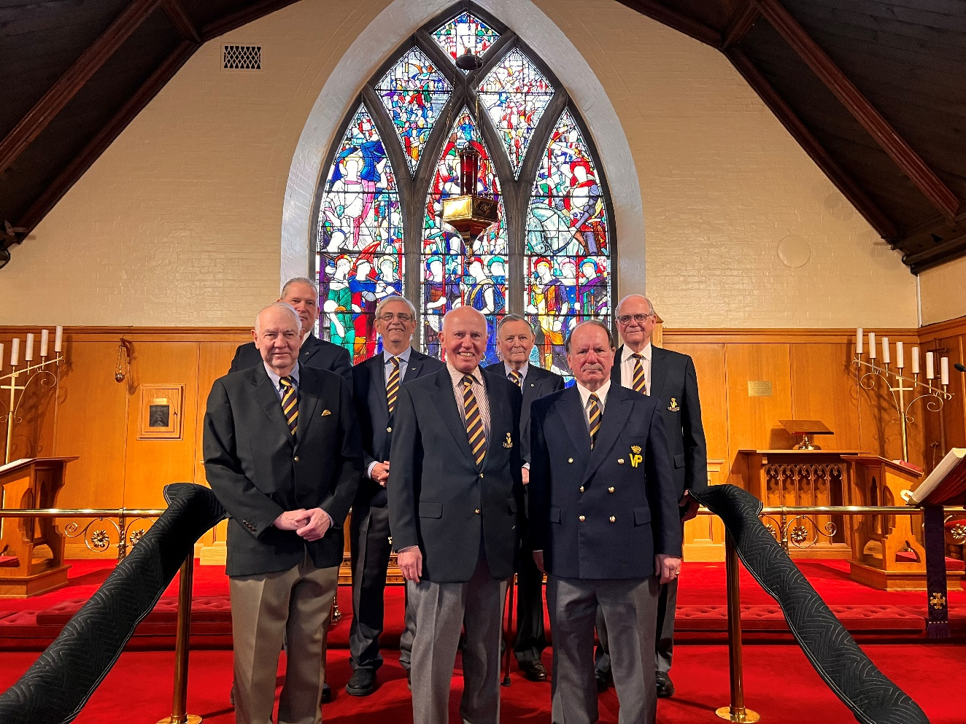
Front (L to R) Al Johnson, Tony Anderson, Vince Kennedy
Rear (L toR) Greg Bell, Dave Pentney, John de Chastelaine, Don Dalziel
The HGMF held its Annual General Meeting at Niagara-on-the Lake on May 13, 2023 in conjunction with the PPCLI Association AGM. We thanked outgoing Trustees Stan Stapleford and Jamie Hammond for their contribution and welcomed Pete Hofman, Bryan Bailey and Shawn McKinstry as new members to the Board of Trustees.
We continued to support PPCLI-affiliated Cadet Corps and congratulate 2837 PPCLI RCACC Yellowknife for winning the 2022/2023 HGMF Cadet Corps Trophy competition. We were also pleased to provide grants of $2,000 each to 553 Sgt Tommy Prince MM PPCLI RCACC Winnipeg, 2837 PPCLI RCACC Yellowknife, and 2943 PPCLI RCACC Campbell River.
The Hamilton Gault Memorial Fund sponsored a hole at the Soldier On Golf Tournament again this year. The Atlantic Branch of the Association benefits from this sponsorship by being able to enter a team in the tournament. The tournament was held at the Royal Oaks golf course in Moncton, NB on August 3, 2023.
In July we were made aware that Lady Patricia’s Medal Group was up for auction in Great Britain. The Hamilton Gault Memorial Fund led the fundraising effort, collecting $8,120 through a GoFundMe campaign and personal donations. The money we raised, with the PPCLI Association’s help, was donated to the Patricia Fund which executed the purchase and provided the balance of the funding. The medal group is now with RHQ, with the unveiling planned to be part of the 110th Anniversary celebrations.
Greg Bell successfully completed the 109th Anniversary Bike Ride fundraiser on August 10, 2023, raising $3,116 for the Hamilton Gault Memorial Fund. Greg began this initiative in 2020 with the 106th Anniversary edition. The 106th to 109th Anniversary Bike Ride fundraisers have raised a total of $31,674, of which 37.6 % or $11,900 was raised by Greg Bell with outstanding support from the Ottawa Branch of the PPCLI Association. The 110th Anniversary Bike Ride fundraiser in 2024 will be the final edition of this event. We encourage all of you to either participate or sponsor a participant to make this final edition a resounding success.
The HGMF Bursary Selection Committee sat on Saturday, 14 August 2023 at the St Albert Legion. The Selection Committee consisted of Pete Hofman (Bursary Vice-Chair) and Derek Prohar (Bursary Chair) and PPCLI Association members Bill Dickson, George Arndt, Herb Kenney, Tim Penney, Paul Wiseman, and Malcolm Thompson. A total of 29 applications were received prior to the deadline, the quality of the candidates was outstanding!
The following 10 individuals who scored the highest in relation to the listed criteria, the bursaries they received, and the respective amounts are as follows:
Steven Campbell: Hamilton Gault – Founder: $4,500
Blake Peloqin: Princess Patricia: $4,500
Connor Elliot: Lady Patricia: $4,500
Megan Campbell: Hamilton Gault Memorial Fund: $2,500
Lucas Bryson: Landing in Sicily: $2,500
Marley Waugh: Leonforte: $2,500
Remington Bracher: Agira: $2,500
Jannelle Sawyer: Sicily 1943: $2,500
Hailey Putnam: Sidney Frost: $2,500
Megan Barden: Pte Cousins: $1,500
St John the Baptist Church at Mersham, England is the final resting place of our second Colonel-in-Chief, Lady Patricia. It is a site of Regimental significance and deserving of our support. The church has two inside plaques: a central one for Lady Patricia; and a second one for her husband Lord John. In November the HGMF purchased a three-year subscription for GBP 150 to the “Friends of Mersham Church” to assist in the maintenance of the church and its grounds.
The HGMF made a $2,500 donation to the Canadian Airborne Forces Association (CAFA) to support it Cyprus 2024 Commemoration project. Details of this project can be found at Cyprus 2024 | CAFA Online (canadianairborneforces.ca).
The Sydney Frost Battlefield Tour will take place 16 to 31 May 2024. 29 individuals are currently registered, and we easily accommodate another 10. The tour will start in Sicily where the Regiment conducted an amphibious assault on 10 July 1943. We will present a replica set of Sydney Frost’s medals to the Carabinieri Museum in Ispica and dedicate a Regimental Memorial at Leonforte. The tour will then transition to Italy, where it will follow the Regiment’s battles as they fought as part 2nd Canadian Infantry Brigade. On 23 May, we will dedicate a Memorial at Hitler Line on the 80th Anniversary of the battle. It was the worst day for 1 Canadian Division during World War II. The Battalion started the day with 324 men and by 1600 hrs, 77 were left standing. The tour will culminate with the dedication of a third Memorial at Osteria Nuova and the opportunity to visit Venice. Additional information can be found at https://hgmf.ca/.

Finally, the HGMF would like to thank all of those who made donations this past year. We received a total of $44,034.50 in 2023, which was invaluable in funding our programs and projects. We would like to thank the PPCLI Association Atlantic, Kingston and Saskatchewan branches for their generous donations.

VP!
Dave Pentney
Chair
Hamilton Gault Memorial Fund

