2022 Hamilton Gault Memorial Fund Annual Report

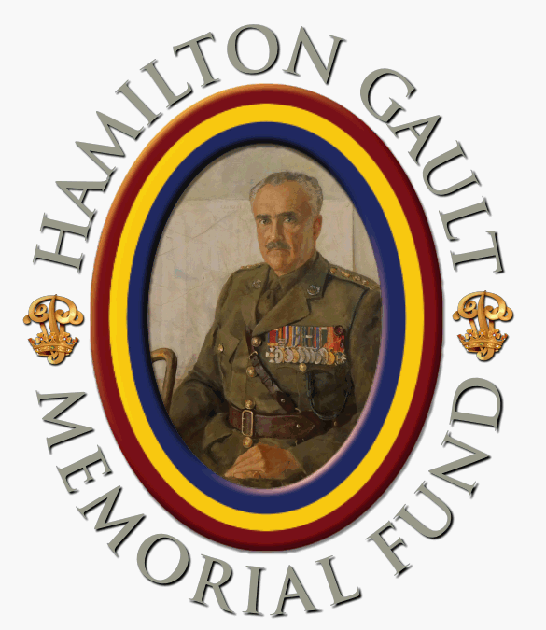
The Hamilton Gault Memorial Fund (HGMF) is named after Brigadier Andrew Hamilton Gault, DSO, ED, CD, Founder of the PPCLI. It is a registered charitable organization that supports the Regiment and the Regimental Family.
In 2022 the HGMF conducted a review of its charitable purposes and activities with a view to better supporting veterans and their families. That review, conducted by our Veterans and Family Support Committee, under the leadership of Donna Campbell, identified several potential new activities. These were subsequently incorporated into a draft set of revised charitable objects and activities that were circulated amongst the Regiment’s governing bodies for comment and subsequent submission to the Canadian Revenue Agency Charities Directorate for approval.
The HGMF sponsored three Compassionate Listening Workshops this year. These provide peer support volunteers, including the PPCLI Association Voluntary Patricia volunteers, with an enhanced set of skills to help veterans get the help they need. Those who attended the workshops have found them very beneficial.
The HGMF Board of Trustees decided to reduce the number of student bursaries this year, but to increase their value to acknowledge the increasing cost of post-secondary education. The theme for the naming of the bursaries was the 20th anniversary of the 3rd Battalion’s Op APOLLO tour, specifically honouring those who lost their lives in the Tarnak Farm friendly fire incident. A total of $30,000 in student bursaries was awarded as follows:
Marlene Waugh: Hamilton Gault Bursary – Founder: $4,500
Connor Elliott : Princess Patricia Bursary: $4,500
Kathleen Gant: Lady Patricia Bursary: $4,500
Lindsay Jone: Hamilton Gault Memorial Fund Bursary: $2,500
Lucas Bryson: Bill Lee (Korea Veteran) Bursary: $2,500
Christopher Plouffe: Sgt Mark Leger Bursary: $2,500
Kaitlyn Paiva: Cpl Ainsworth Dywer Bursary: $2,500
Chloe Panych: Pte Richard Green Bursary: $2,500
Mikenna Smith: Pte Nathan Smith Bursary: $2,500
Eden Weaver: Op Apollo 20th Anniversary Bursary: $1,500
We express our thanks to the PPCLI Association for their continued assistance in delivering the student bursary program. A total of $30,000 has been allocated for the 2023 program.
Our support to PPCLI affiliated Cadet Corps was limited for the first part of the year because of COVID; however, with restrictions now lifted the cadet corps are parading again and we have initiated the 2022/23 HGMF Cadet Corps Trophy Competition. We are also soliciting 2023 grant applications from the Cadet Corps.
The memorial for Jack Monroe, one of the Originals, was installed this spring. Thank you to Greg Ferguson of the SW Ontario of the PPCLI Association for leading this project and for all those who donated to it.
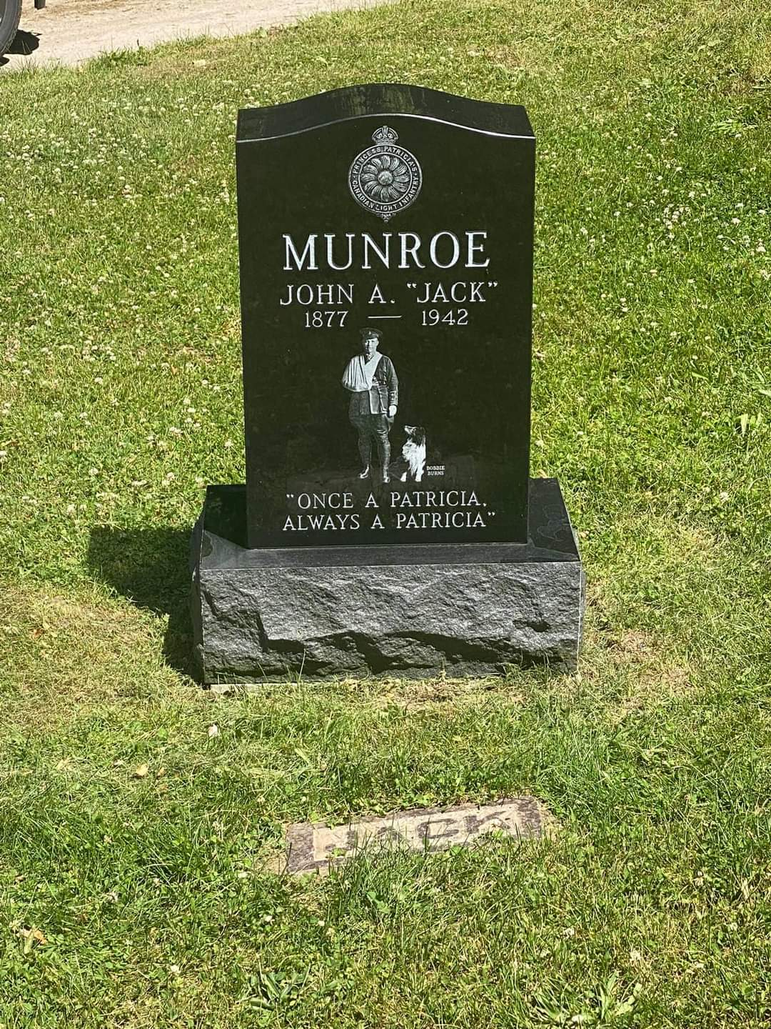
As reported in last year’s edition, the HGMF has also agreed to fund 10% of the estimated $250,000 refurbishment of the St. Bartholomew’s Church Stained Glass Window. There is a very strong Patricia connection with this church, and in particular with this stained-glass window, even though it dates back more than a century. The restoration work has been completed and Don Dalziel reports that it looks amazing. As of writing the HGMF has raised $21,720 towards this project. A cheque will be delivered for $20,000 by the end of the year with the remaining $5,000 being formally presented to the church early in 2023.
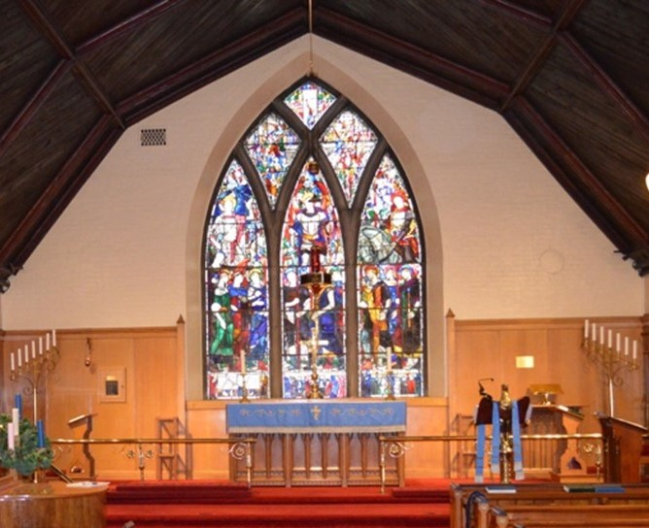
Detailed planning continues for the Sydney Frost Battlefield Tour of Sicily and Italy slated for 2024. This will be an outstanding historical tour of PPCLI WWII Italian Campaign battlefield sites. Information will be available in March 2023 on how you can participate in that tour. The HGMF will sponsor the participation of as many cadets as possible, depending on the amount of funds we can raise. The approximate cost per cadet is $6,000.
The HGMF, as a charity, depends on your donations to support our programs. Donations may be made in a variety of ways. You can mail a cheque, payable to the Hamilton Gault Memorial Fund to Hamilton Gault Memorial Fund, C/O The Military Museums, 4520 Crowchild Trail SW, Calgary, AB T2T 5J4. You can make an online donation through CanadaHelps (https://www.canadahelps.org/en/charities/hamilton-gault-memorial-fund/) or you can send an e-transfer to cfo.hgmf@gmail.com. You can also direct your United Way contribution to the HGMF.
Finally, I want to express my personal thanks, and that of the Board of Trustees, to Chuck Recce who has served as our Vice-Chair. Chuck has, unfortunately had to resign from the board for medical reasons. We thank him for his service to the HGMF and to the Regiment and we wish him well.

VP!
Dave Pentney
Chair
Hamilton Gault Memorial Fund

